A sample documentation on nopCommerce theme customization process; Along with that, there are samples of the customized pages.

nopCommerce Theme Customization



**Mahesh Singh Madai**

**9th April,2022**

Catalog

**nopCommerce Download & Installation 3**

**Theme customization** 3

Default Theme 3

Custom Theme Setup 3

Customization 4

# nopCommerce Download & Installation

* Download the desired nopCommerce zip from the official nopcommerce site

<https://www.nopcommerce.com/en>

OR

* From the git repository (https://github.com/nopSolutions/nopCommerce/releases)

After download, unzip the folder and run the solution file.

Launch the server in the visual studio.The installation page appears. Input the credentials and press install.

# Theme customization

## Default Theme

For the theme location, go to **Presentation/Nop.Web/Themes/** At default, there is only one theme titled DefaultClean. The folder structure is as follows

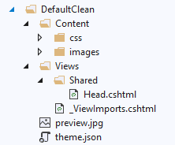

## Custom Theme Setup

For making your own theme, copy and paste the DefaultClean folder and rename it.(Here, I renamed it NewTheme)

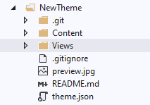

First, go into ***theme.json*** file and change the properties as shown below

DefaultClean/theme.json

{

"SystemName": "DefaultClean",

"FriendlyName": "Default clean",

"SupportRTL": true,

"PreviewImageUrl": "~/Themes/DefaultClean/preview.jpg",

"PreviewText": "The 'DefaultClean' site theme"

}

NewThem/theme.json

{

"FriendlyName": "New Theme",

"PreviewImageUrl": "~/Themes/NewTheme/preview.jpg",

"PreviewText": "The 'NewTheme' site theme",

"SupportRTL": true,

"SystemName": "NewTheme"

}

## Customization

For customizing the views, the step that you need to follow for every views is: Copy the view you want to customize from Presentation/Nop.Web/Views into your theme’s view folder (example. Presentation/Nop.Web/Themes/NewTheme/Views)

For example, if you want to change the logo of the website, copy the Views/Shared/Components/Logo folder into your Themes shared folder. (NewTheme/Views/Shared/Logo)

